Handout no. 05

|  |  |
| --- | --- |
| **Name** | M.Umar Saleem, M.Usama, Abdul Jabbar |
| **Reg. No** | 2019-EE-356,366,376 |
| **Marks/Grade** |  |

**EXPERIMENT # 05**

**Parameter setting of Under Voltage & Over Voltage Time Relay**

**Objective:**

At the end of this lab session students will be able to

* Use De Lorenzo power system Protection kits.
* Implement Under Voltage & Over Voltage Time Relayby using De Lorenzo power system Protection kits.
* Relay behaviour in three phase systems for Under Voltage & Over Voltage conditions.
* Determination of resetting ratio

**Introduction:**

A relay is usually an electromechanical device that is actuated by an electrical current. The current flowing in one circuit causes the opening or closing of another circuit. Relays are like remote control switches and are used in many applications because of their relative simplicity, long life, and proven high reliability. Relays are used in a wide variety of applications throughout industry, such as in telephone exchanges, digital computers and automation systems. Highly sophisticated relays are utilized to protect electric power systems against trouble and power blackouts as well as to regulate and control the generation and distribution of power. In the home, relays are used in refrigerators, washing machines and dishwashers, and heating and air-conditioning controls.

Although relays are generally associated with electrical circuitry, there are many other types, such as pneumatic and hydraulic. Input may be electrical and output directly mechanical.All relays contain a sensing unit, the electric coil, which is powered by AC or DC current. When the applied current or voltage exceeds a threshold value, the coil activates the armature, which operates either to close the open contacts or to open the closed contacts. When a power is supplied to the coil, it generates a magnetic force that actuates the switch mechanism

**Apparatus:**

* 1DL 1013T1 Experimentation Transformer
* 1DL 2108T12 Under Voltage & Over Voltage Time Relay
* 1 DL 2109T3PV Moving iron voltmeter
* 1 DL Buz Acoustic continuity tester

**Voltage Transformers:**

For the satisfactory working of all [electrical and electronic devices](https://www.elprocus.com/basic-components-used-electronics-electrical/), it is recommended to allow voltage at prescribed limits. Voltage fluctuations in electric power supply certainly have adverse effects on connected loads. These fluctuations can be of over voltage and under voltages which are caused by several reasons like voltage surges, lightning, overload, etc. Over voltages are the voltages that exceed the normal or rated values which cause insulation damage to electrical appliances leading to short circuits. Similarly, under-voltage causes overloading of the equipment leading to lamp flickers and inefficient performance of the equipment. This voltage protection circuit is designed to develop a low-voltage and high-voltage tripping mechanism to protect a load from any damage. In many of the homes and industries fluctuations in AC mains supply take place frequently. The electronic devices get easily damaged due to fluctuations. To overcome this problem, we can implement a tripping mechanism of under / overvoltage protection circuit to protect the loads from the undue damage.

Thus, this article is intended to give [under and overvoltage protection circuit](https://www.elprocus.com/voltage-electrical-short-circuit-prevention/) schemes with different control structures.

[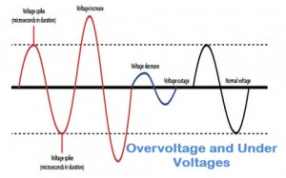](https://www.elprocus.com/wp-content/uploads/2014/08/feat.jpg)

**VM:** Maximum set point, have dial to set % of nomial voltages from 0 to +20%

**Vm:** Minimum set point, have dial to set % of nomial voltages from 0 to -20%

**Vn:** Dial is available for nomial voltage of three phase system to select appropriate from available(380V,400V,415V)

**TM**: Dial is available for setting delay time for over voltage conditions

**Tm:** Dial is available for setting delay time for under voltage conditions

**Indications:**

ON : Green LED, supply on

AM: Red LED, set point VM has reached

Am: RED LED, set point Vm has reached

**Under Voltage & Over Voltage Time Relay Basic Diagram:**

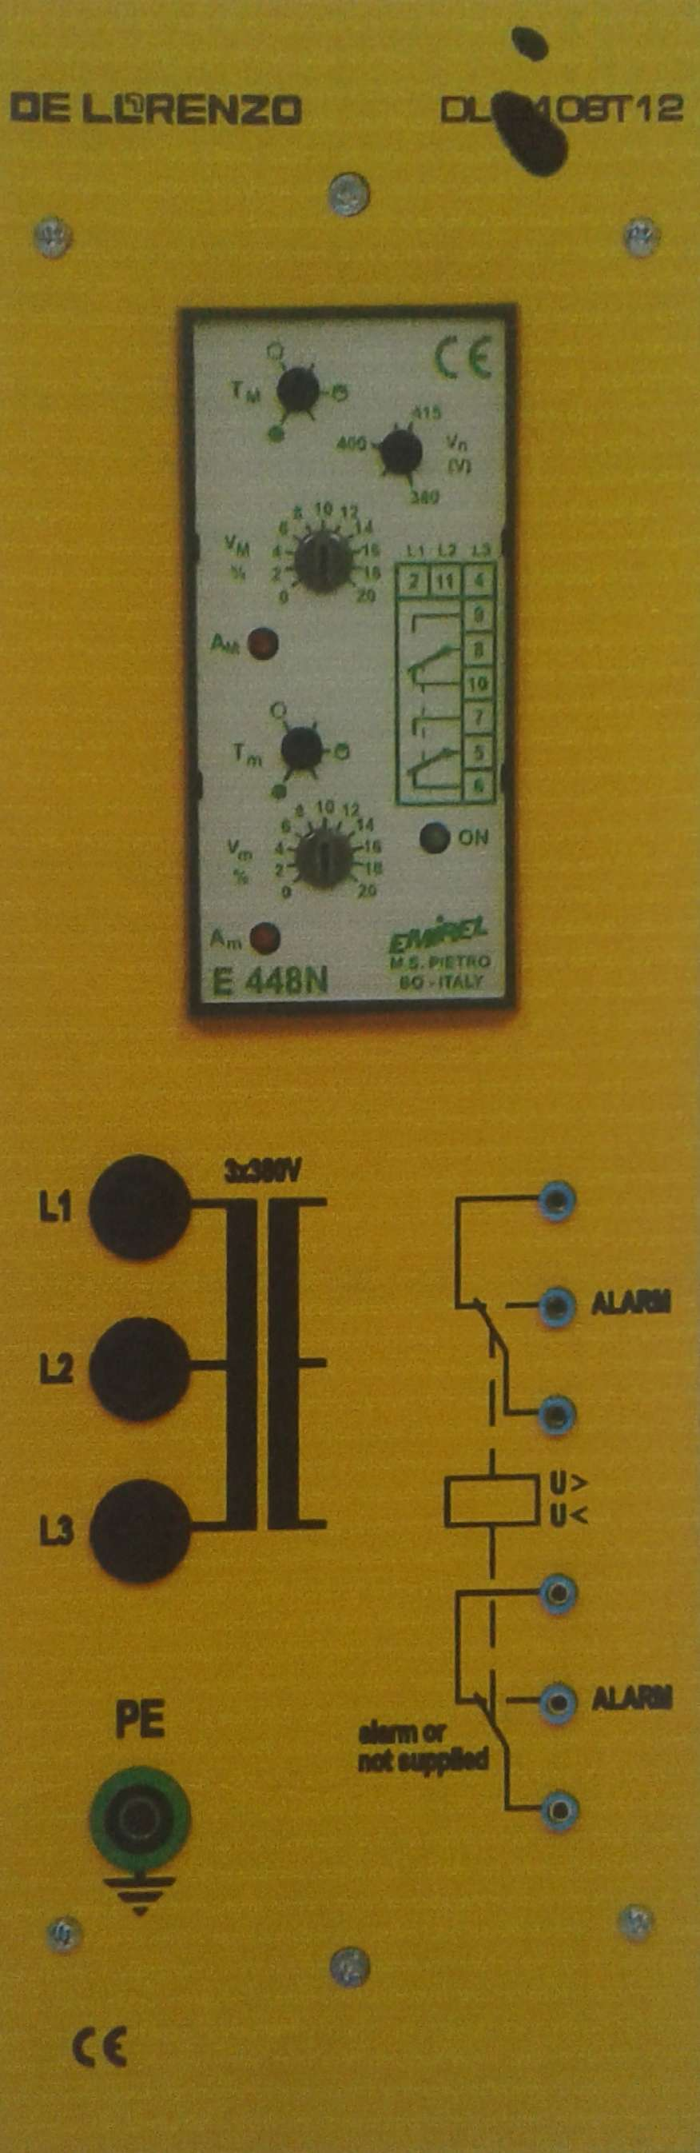

Figure 1 : VT internal wiring Diagram

***Circuit construction:***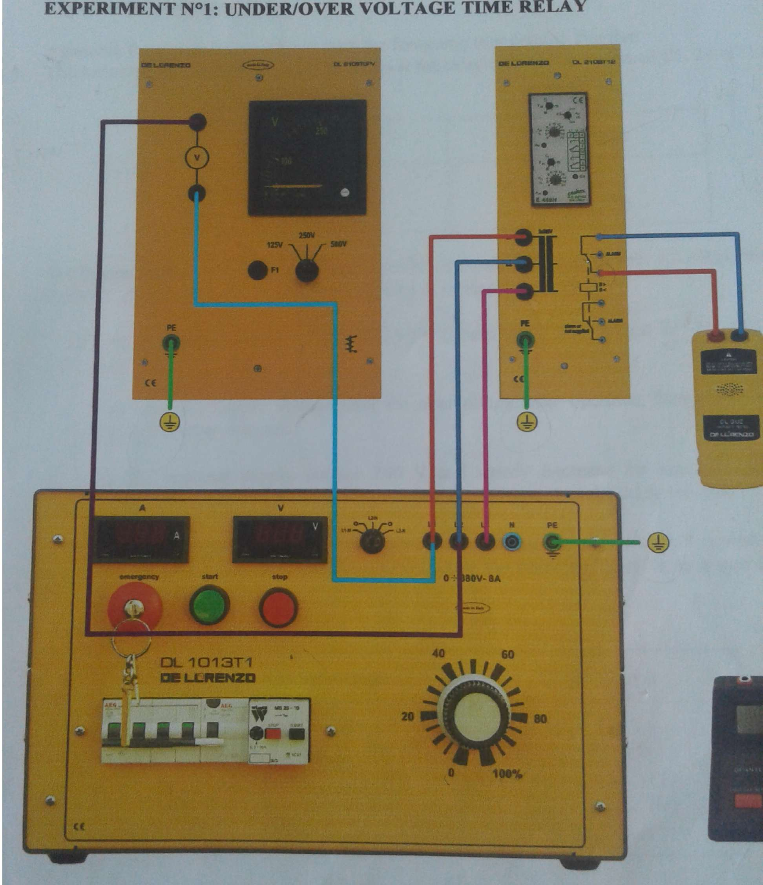 Figure 2: Under Voltage & Over Voltage Time Relay circuit

**Procedure:**

**Procedure:**

* Connect circuit as shown in Fig 2.
* Set three phase power supply voltage 380v and relay is not in operation
* Observe over voltage reference voltage w.r.t to three phase supply.
* Slowly increase supply voltage until overvoltage condition reaches and relay operates
* Slowly decrease the voltage until relay releases and note V0 release voltage and find Kr which is release ratio.
* Observe under voltage reference voltage w. r .t to three phase supply.
* Slowly decrease supply voltage until under voltage condition reaches and relay operates
* Slowly increase the voltage until relay releases and note V0 release voltage.
* Apply same procedure for different timer conditions

**Table 1:**

|  |  |  |  |  |  |  |  |
| --- | --- | --- | --- | --- | --- | --- | --- |
| **Over Volatge conditions** | | | | **Under Voltage conditions** | | |  |
| **%age** | **8** | **10** | **14** | **%age** | **8** | **10** | **14** |
| **VO** | **415** | **432** | **445** | **VO** | **375** | **365** | **344** |
| **Vr** | **404** | **414** | **432** | **Vr** | **384** | **376** | **362** |
| **Kr** | **1.02** | **1.04** | **1.03** | **Kr** | **0.976** | **0.97** | **0.95** |

**Observation:**

In this Lab we have learnt about the Use of De Lorenzo power system Protection kits.

And how to Implement Under Voltage & Over Voltage Time Relayby using De Lorenzo power system Protection kits.

We have also observed the Relay behaviour in three phase systems for Under Voltage & Over Voltage conditions and determination of resetting ratio.

We learnt about Under and Over Voltage Time Relay. First, we made connections on Hardware according to the given instructions.

Then, we noted the reading of under voltage condition and noticed the all value at which the light start to bright down and notice that point of voltage the tripping point at which light gets off and the we start the process for the over voltage time delay gradually increase the value so that we can achieve that point at which light get dim and tripping point After that, we theoretically calculated the value of our voltage and compared it with the observed one.

At the end, we converted the 3-phase voltage readings into 1-phase and attached the readings with our manual and find calculated the error **Kr**.